Literature 510 – Victorian Literature
The Ecocriticism of Charles Dickens’s Oliver Twist

By: Reginald Andah

Presented To:
Dr. Spencer
Southern New Hampshire University

8/26/2023
9-2 Final Project Submission: Final Research Paper
Queen Victoria’s reign lasted from the year 1837 to 1901. During the Victorian era, invention, imperialism, and industrialism were at an all-time high when referring to the British economy and infrastructure. Because of such a transformative social change, writers sought to capture the condition of its people through their novels. One such novel was Charles Dickens’s Oliver Twist. The reader is introduced to a boy of humble backgrounds in a society where the lower class is expendable. Before industrialization, there were shelters for the less fortunate to rest, socialize, and essentially rejoice as a community. After industrialism, magistrates took over shelters, turning them into workhouses where people were fed just enough gruel to function. Because of such hardship, the subjugated people never made enough wages to create a better life for themselves. A young Charles Dickens witnessed such cruelties, allowing him to create a realistic fictional interpretation of the societal state by portraying its environment through his works. Dickens uses Oliver to symbolize the ecocriticism of the Victorian age when he experiences abuse, lower socio-economic status, and poor living conditions the lower-class struggled to survive in under the Poor Law Act of 1834.
Dickens portrays the abuse under the Poor Law Act by using Oliver like a conduit of sorts to the reader; depicting the corruption of the environment through the main character. After being cared for by “church wardens and overseers” (Dickens Chapter I), Oliver finds himself in a “systematic course of treachery and deception… The hungry and destitute situation of the infant orphan was duly reported by the workhouse authorities to the parish authorities…the consolation and nourishment of which he stood in need” (Dickens Chapter II). The workhouses contributed a great deal to the abuse of orphans and other lower-class people like him. Ruth Richardson’s Oliver Twist and The Workhouse expresses this sentiment and how such a system was mandated on its citizens:
Instead of providing a refuge for the elderly, sick and poor, and instead of providing food or clothing in exchange for work in times of high unemployment, workhouses were to become a sort of prison system. The government's intention was to slash expenditure on poverty by setting up a cruelly deterrent regime. (Richardson par.5)
The parliament of the Victorian era was set in motion to benefit the more fortunate and to abuse those in poverty. Mandates and legislation implemented during this period reflected this notion. Scholars further support the abuse of the period as Sambudha Sen states in his article “Lack of proper clothing carried an even deeper capacity to humiliate and to isolate the poor in the years after the passage of the New Poor Law in 1834” (Sen 238). The humiliation depicted and used as propaganda to segregate the poor added to the abusive treatment of them. According to a video presentation of Literature in the Victorian Era | a Historical Overview, more than seven thousand authors were compelled to create literature reflecting their time. The Poor Law Act was a popular topic. It was an Act of the Parliament of the United Kingdom which established the workhouse organization. Queen Victoria came to power in the middle of the world’s first industrial revolution. Although the middle class flourished from this development, the poorer lower class did not. The workhouse became a system of intense labor the poor did in exchange for meagre food scraps and shelter. Also, the poor had to live in workhouses as well. They didn’t have a choice since the exchange for their labor was barely enough to survive. Because of such trying times, abuse became apparent.
Similar reflections of this abuse are portrayed in Oliver Twist. Perhaps the most famous line of this story is said by Oliver when requesting to the server “‘Please, sir,’ replied Oliver, ‘I want some more’” (Dickens Chapter II). The line acts as one of the most significant representations of the abuse that was propagated by the Poor Law Act. After laborers in the workhouses were already malnourished, the kids dared Oliver to ask for more. Not only is the abuse of the workhouses highlighted but also the hypocrisy as the master serving the food was “a fat, healthy man… He gazed in stupefied astonishment… The assistants were paralysed with wonder; the boys with fear” (Dickens Chapter II). Readers are also given a visual representation of the event within the narrative:
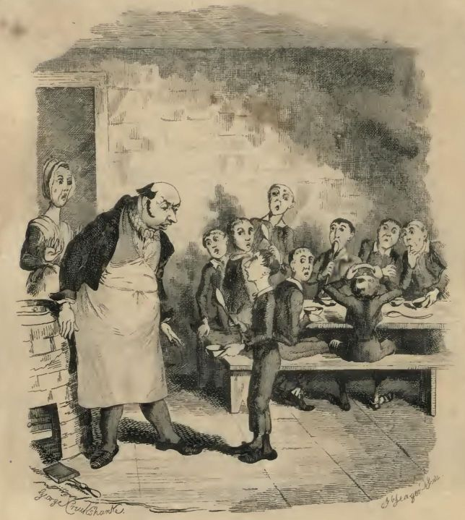
(Image presented by: gutenberg.org/files)
The visual aid gives credence to the abuse since the reader can see how much healthier the authorities were compared to the common lower-class citizens. Knowing this unfair treatment, the abuse is taken further as the reader comes upon the exchange between the master and the authorities due to Oliver’s inquiry of requesting more food. When taking into consideration his already malnourished state, the reader is prompted to feel empathy for Oliver’s abuse:
The master aimed a blow at Oliver’s head with the ladle; pinioned him in his arm; and shrieked aloud for the beadle. The board were sitting in solemn conclave, when Mr. Bumble rushed into the room in great excitement, and addressing the gentleman in the high chair, said,
‘Mr. Limbkins, I beg your pardon, sir! Oliver Twist has asked for more!’
There was a general start. Horror was depicted on every countenance.
‘For more!’ said Mr. Limbkins. ‘Compose yourself, Bumble, and answer me distinctly. Do I understand that he asked for more, after he had eaten the supper allotted by the dietary?’
‘He did, sir,’ replied Bumble.
‘That boy will be hung,’ said the gentleman in the white waistcoat. ‘I know that boy will be hung.’ (Dickens Chapter II)
Not only does the master strike Oliver’s head with a ladle and pin his arm, even though he did nothing but beg for more food, but Oliver is also threatened with death in the form of hanging. Perhaps the magistrates didn’t want others to get the idea of asking for more either as it would disrupt the working-class system they had in place. Such an extreme is seen as ludicrous by today’s standards. However, if we delve into the history during the Victorian age, such treatment was a norm.
In his Oliver Twist and The Workhouse, Richardson highlighted the abusive events of not only the previously mentioned chapter of Dickens’s Oliver Twist, but also, the ones that follow:
The description of Oliver's punishments for his request – a natural entreaty from a growing boy… The sheer brutality of the system is exposed. Oliver is maligned, threatened with being hanged, drawn and quartered; he is starved, caned, and flogged before an audience of paupers, solitarily confined in the dark for days, kicked and cursed, hauled up before a magistrate and sent to work in an undertaker's, fed on animal scraps, taunted, and forced to sleep with coffins. (Richardson par. 3)
Though the entirety of Richardson’s statement isn’t necessary to get the gist of the abuse, emphasizing all the acts committed to Oliver for his one inquiry highlights the extent of mistreatment inflicted upon the laborers. After viewing the history of the period, the abuse within the environment of the lower-class Dickens illustrates through Oliver is a realistic depiction of the Poor Law Act of the Victorian era. Richardson again echoes this illustration by describing the Poor Law Unions:
Groups of parishes - called Poor Law Unions – were formed under the new system, and a network of workhouses was established across the country… The regime inside these places was deliberately intended to deter everyone but the most desperate. Children were separated and sent away, heads were shaved, clothes boiled, uniforms issued... Dickens shows that the administration was run by self-satisfied and heartless men. (Richardson par. 6)
Oliver represents these children in Richardson’s description whom Dickens uses to symbolize the impoverished people who faced such abuse under the parliament due to the Poor Law Act of 1834.
When reading more into Oliver’s disparaging plight, the reader can see the result of what being born in a lower socio-economic status does to the less fortunate through Oliver’s experiences. When under the care of the Sowerberrys, Mrs. Sowerberry interacts with Mr. Bumble who tries to almost sell Oliver’s worth to them. Due to his lower socio-economic status, Oliver is barely treated with dignity or respect. Mrs. Sowerberry iterates to Mr. Bumble, “I see no saving in parish children, not I; for they always cost more to keep, than they’re worth” (Dickens Chapter IV). The reader can interpret that there wasn’t an equipped or adept adult supervisor for children who needed help like Oliver. Other researchers of the Victorian age such as Geoffrey A.C. Ginn also comments on the evident social inequality. Ginn points out the “labouring poor ‘were subjected to a package deal from those above them…which asked…’not what is to be done, but what can I do’ about widespread, visible and troubling urban poverty” (Ginn 3). The hypocrisy of the middle and upper class that created the mindset of putting all the work of society’s issues on the lower-socio economic class (the poor) was incomprehensible. When Oliver finds himself in the company of Mr. and Mrs. Sowerberry after the court’s deliberation of where he should go, the couple speak of how they can use Oliver to benefit their funeral home business:
‘There’s an expression of melancholy in his face, my dear,’ resumed Mr. Sowerberry, ‘which is very interesting. He would make a delightful mute, my love.’
Mrs. Sowerberry looked up with an expression of considerable wonderment. Mr. Sowerberry remarked it and, without allowing time for any observation on the good lady’s part, proceeded.
‘I don’t mean a regular mute to attend grown-up people, my dear, but only for children’s practice. It would be very new to have a mute in proportion, my dear. You may depend upon it, it would have a superb effect.’
Mrs. Sowerberry, who had a good deal of taste in the undertaking way, was much struck by the novelty of this idea. (Dickens Chapter V)
Oliver is looked at more as an asset for the couple’s personal ventures than he is a boy with human characteristics due to his lower socio-economic status. This is especially true when considering that Mr. Sowerberry, the undertaker, calls Oliver “it” rather than addressing him by his name. In Plural Perspectives: A Study of Oliver Twist, Iman Abdullah Yahya Al-Mahdi further discusses how such a low socio-economic status leads to social alienation. Al-Mahdi explains “In the life of Oliver, Dickens has drawn…alienation-socialization much more prominently, clearly and intensely” (Al-Mahdi 5). Society in the Victorian era was similar as people felt alienated due to their low socio-economic status. Yet, they still had to persist in an unforgiving society to survive. Al-Mahdi argues as well that such alienation and division of social classes were necessary for the Victorian era to succeed. This contradiction allowed the middle class, magistrates, and other higher hierarchies to flourish and thrive. However, the lower-class struggled to live. Oliver even encountered people so embedded within the hardship of the lower-class, they resorted to thievery. He stood in horror at the boys he was acquainted with as he saw “the Dodger plunge his hand into the old gentleman’s pocket, and draw from thence a handkerchief! To see him hand the same to Charley Bates…both running away round the corner at full speed” (Dickens Chapter X)! An illustration is also provided:
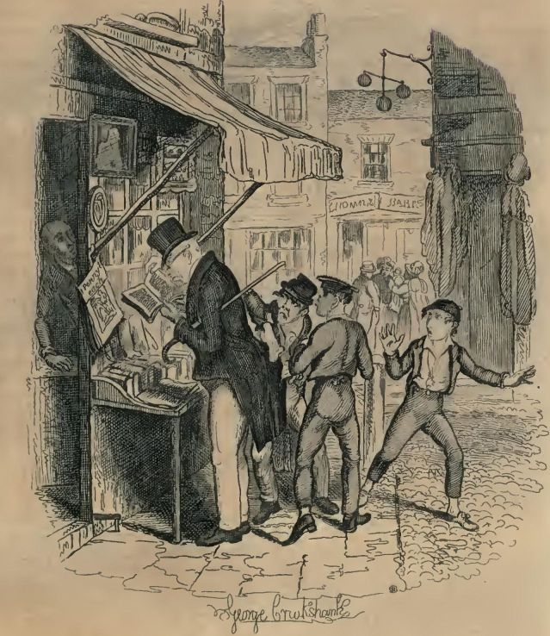
(Image presented by: gutenberg.org/files)
When viewing others’ critiques of the economy, other studies support the alienation of the low socio-economic status as well. David Amigoni points out that “the ideal of harmony was shadowed by the presence of alien others. These included impoverished outcasts, for as well as being sites of great energy Victorian cities were also places of terrible poverty and crime” (Amigoni 5). This paradox is seen with the Sowerberrys as well. Although they run a funeral business for a variety of clientele, they take advantage of the dead and reap the benefits of the lower socio-economic class and their circumstances. Oliver is a symbol of the lower-class while the Sowerberrys are symbols of the middle and upper class who take advantage of their labor. As expressed by other scholars, such paradoxes depicted by Dickens were a regular occurrence that contributed to the overall economic state and environment of the Victorian period. Studies such as The Imagination of Class: Masculinity and the Victorian Urban Poor convey “London’s poor came to exercise a strong imagistic influence, shaping the discourses of journalism, social work, government activity, and high culture” (Bivona and Henkle 1).
Dickens himself was a witness and somewhat recipient of the lower socio-economic class. Thus, he wrote novels in good faith to discuss and put a spotlight on such issues. We can see this in resources such as Characteristics of Victorian Era Literature, Novels and Poetry. In a caption of Charles Dickens’s life, the reader is introduced to some of his upbringing:
Dickens saw a lot of poverty in his early life, from his father being riddled with debt to the entire family being sent to something known as a debtors prison, where young Charles was forced to work for long hours. The hard and dangerous work left a lasting impression on Charles Dickens, who would later incorporate in his writings a sense of social injustice that was endemic in Victorian Britain. (Victorian Novelist Charles Dickens Biography, Life And Education par.7-8)
By discussing his negative critiques of the Victorian age through his stories such as Oliver Twist and using Oliver as the symbolism of its ecocriticism, Dickens brings light to the low-socioeconomic status and how those people were treated. M.J. Booklover’s Reading English Victorian Literature: A Brief Guide to the Classics addresses how having such a status during this period put a toll on the working class. Due to industrialization, a lot of “These rapid changes eventually led to widespread prosperity and growth of the middle class, but the beginning of the era brought social dislocations and many hardships to working class people” (Booklover 1832-1848: “Time of Troubles”). The strain of such changes bore down on the working-class people – the lower socio-economic class. Booklover continues that “Living conditions in city slums that housed the era’s new factory workers were horrendous, and hunger was rife. There were few regulations on working conditions, which were terrible not only for men but for women and children as well” (Booklover 1832-1848: “Time of Troubles”). Situations such as the ones described here were seen within the narrative through Oliver’s environment as well. The ecocriticism explored within the narrative is a clear realistic representation of the lower class within the Victorian era.
Being an individual of the lower-socio economic status was not for the faint of heart. Their environment contradicted the middle class and suburban neighborhoods they were not akin to. When reading studies such as The Infrastructural Uncanny: "Oliver Twist" in the Suburbs and Slums, scholars can again clearly see the depictions of such a paradox come to light. Justin Eichenlaub highlights “The city’s suburbs and slums were economic and social doubles; the size and comforts of suburban housing were inversely related to the cramped shapes and discomforts of slum tenements” (Eichenlaub 2). Throughout the narrative of Oliver Twist, the reader comes across references to the poor living conditions. For instance, “In some villages, large painted boards were fixed up: warning all persons who begged within the district, that they would be sent to jail” (Dickens Chapter VIII). The reader can interpret that begging from the less fortunate was a regular practice. So much so that even villages boarded up their houses not to be bothered with beggars. Instead of acting against such a social injustice, Victorian society would rather ignore it and pretend like it didn’t exist. Dickens’s portrayal of such an environment still rings true within present-day society.
When referring to the ecocriticism of the lower-socio economic status, we find Oliver in the most rueful of places where it is unkempt and unclean. One instance, when Oliver is wrongfully in prison for a crime he did not commit, Dickens takes the liberty as the narrator to not only describe the cell but compare it to dungeons:
something like an area cellar, only not so light. It was most intolerably dirty; for it was Monday morning; and it had been tenanted by six drunken people, who had been locked up, elsewhere, since Saturday night. But this is little. In our station-houses, men and women are every night confined on the most trivial charges—the word is worth noting—in dungeons, compared with which, those in Newgate, occupied by the most atrocious felons, tried, found guilty, and under sentence of death, are palaces. Let any one who doubts this, compare the two. (Dickens Chapter XI)
His tone toward the end of this statement emphasizes to the audience that the cells for criminals were in inhumane standards for Oliver, who again, represents the lower class.
When exploring the ecocriticism of the Victorian age pertaining to the lower socio-economic status, in texts such as Victorian Writers and the Environment: Ecocritical Perspectives, studies show that “Dickens ‘observes with gusto the humanness of humanity as exhibited in the urban (and suburban) scene’… Dickens offers ‘an imaginative judgement…of social attitudes” (Mazzeno and Morrison 98). In scenes expressing the urban scene such as Oliver in the cell, the reader is placed in this fictional world where the audience is also privy to the humanness of humanity (or lack of) portrayed by Dickens that is represented through Oliver’s experiences. Dickens continues to echo the ill-fate of the lower socio-economic status with depictions throughout the narrative of Oliver Twist. Also, due to Dickens’s experiences and first-hand accounts of the Victorian period, he can give a realistic depiction of the lower class’s economic status throughout his work. His biography written by C.D. Merriman expresses “he was rudely introduced to the world of the working poor, where child labour was rampant. Many of his future characters like Oliver Twist…would be based on his own experiences” (Merriman par. 5).
When further analyzing the poor living conditions of the environment pertaining to the Victorian society Dickens depicted, briefly going back to Richardson’s Oliver Twist and The Workhouse, he makes many points toward the living conditions and how Oliver’s surroundings reflect it pertaining to ecocriticism. There’s a passage he conveys that really drives home the intentions of the government saying that “The old parish poorhouses and almshouses were to be completely changed, no cash support whatever would henceforth be given out…and the old gifts in kind (food, shoes, blankets) which could help a family survive together, were now disallowed” (Richardson par.5) A blatant intention to keep the working class in poor conditions, on the government’s part, is depicted here. Though an immoral act to humanity, such practices were not only treated as lawful but enforced, which divided families. The living conditions were in such peril that:
Charitable hospitals generally refused access to those suffering from chronic (incurable) conditions, dying patients, and paupers. So workhouse inmates were often people whose medical conditions were regarded as hopeless at the time, and whose social status debarred them from other kinds of help. (Richardson par. 7)
Oliver is also treated as a victim of his poor living conditions as his half-brother, Monks, later in the story tries to take Oliver’s half of his family’s inheritance due to their poverty-stricken state. The reader can already interpret Monks’s greed seethe through the dialogue he has with Mrs. Bumble:
‘About the mother of the boy you named,’ replied the matron interrupting him. ‘Yes.’
‘The first question is, of what nature was her communication?’ said Monks.
‘That’s the second,’ observed the woman with much deliberation. ‘The first is, what may the communication be worth?’
‘Who the devil can tell that, without knowing of what kind it is?’ asked Monks.
‘Nobody better than you, I am persuaded,’ answered Mrs. Bumble: who did not want for spirit, as her yoke-fellow could abundantly testify.
‘Humph!’ said Monks significantly, and with a look of eager inquiry; ‘there may be money’s worth to get, eh?’ (Dickens Chapter XXXVIII)
Through this exchange, the reader can see how Monks prioritizes money and how the situation will benefit him. People would rather take advantage of their own family members to escape the poor living conditions rather than act as a unit to survive during this period. The lack of empathy is also echoed in other instances such as when Oliver is being tracked by thieves. A quick back and forth of dialogue displays their apathy for Oliver:
The young thieves eyed their preceptor as if they were alarmed at his violence; and looked uneasily at each other. But they made no reply.
‘What’s become of the boy?’ said the Jew, seizing the Dodger tightly by the collar, and threatening him with horrid imprecations. ‘Speak out, or I’ll throttle you!’” (Dickens Chapter XIII)
The “boy” being referred to, Oliver, is who they are looking for to use. This predicament is no different than the one Oliver found himself in with the Sowerberrys. They viewed him as an “it” to benefit their own self-interests.
One can argue that the poor living conditions symbolized through Oliver brought out the worst in these people who had to suffer in it. Eichenlaub conveys “Oliver, the thieves, and their upper-middle-class pursuers partake of a newly threatening city flimsily divided by the real and imagined contours of interlinked urban zones” (Eichenlaub 5). These divisions of interlinked urban zones contributed to the destitute situation of the Victorian era when referencing its connection to ecocriticism. The same state of the economy is continuously represented throughout Oliver’s experiences of his environment as the reader ventures further into the narrative. He observes “In the obscure parlour of a low public-house, in the filthiest part of Little Saffron Hill; a dark and gloomy den, where a flaring gas-light burnt all day in the winter-time; and where no ray of sun ever shone in the summer” (Dickens Chapter XV). Low public-houses were in similar condition during this period. The streets, oddly enough, complimented the houses’ sad state:
At length they turned into a very filthy narrow street, nearly full of old-clothes shops…stopped before the door of a shop that was closed and apparently untenanted; the house was in a ruinous condition, and on the door was nailed a board, intimating that it was to let: which looked as if it had hung there for many years. (Dickens Chapter XVI)
These two instances depict how Oliver’s environment is a direct representation of the poor living conditions of Victorian society. The negative representation of the environment reflects the struggle the poor had to endure. The neglect of the lower-class society is apparent as the middle class and magistrates thrived off the working class’s labor. Dickens, who witnessed the effects of the Poor Law Act during his time, observed this type of behavior throughout his life. Because of the social injustice, he felt compelled to write stories about the living conditions to make the public aware of the unequal treatment of its own citizens within their society. To cement his legacy as such an advocate, inscribed on his tomb reads “He was a sympathiser to the poor, the suffering, and the oppressed; and by his death, one of England’s greatest writers is lost to the world” (Merimman par. 11).
Other texts of online literature pertaining to Dickens also portray him as an advocate for those in poor living conditions and why he felt compelled to write characters such as Oliver to represent the societal issue. Symbolizing such ecocriticism within his stories became his common trope:
“As a prolific 19th Century author of short stories, plays, novellas, novels, fiction and…became known the world over for his remarkable characters, his mastery of prose in the telling of their lives, and his depictions of the social classes, mores and values of his times.” (Merriman par.1)
Because of his mastery of prose and his ability to relate the realism of society through his fictional work, he became an influential talent in the hearts of many that allowed him to communicate the poor living conditions through such characters as Oliver Twist.
Different encyclopedias also refer to how Dickens is notoriously known for how his works “deal with the plight of the poor and oppressed” (New World Encyclopedia par.3). While writing his influential works, there was a huge population growth along with the industrial revolution. The Darwinian revolution also emerged as referred to in Introduction to Victorian Literature: Overview of Themes, Style, and Authors. Therefore, society was ironically going through its own evolution where people such as authoritative figures were more focused on advancing in a rapidly changing world rather than stopping and seeing what such change was doing to the lower class. When taking these events of the Victorian age into consideration, scholars in this field can start to see how the Poor Law Act of 1834 took effect in the first place. These types of significant changes were the catalysts that caused Charles Dickens to convey the state of the economy through novels such as Oliver Twist. By using the main character as a representation of the lower-class, the reader can conclude how Oliver's abuse, lower socio-economic status, and poor living conditions as an orphan symbolized the ecocriticism of the period. Hence, Oliver represented the struggle the lower class went through to survive under the Poor Law Act within a realistic, yet fictional, depiction of his environment.

Works Cited
Al-Mahdi, Iman Abdullah Yahya. “Plural Perspectives: A Study of Oliver Twist.” Ebsco.com, Writers Editors Critics, 1 Mar. 2012, eds-p-ebscohost-com.ezproxy.snhu.edu/eds/pdfviewer/pdfviewer?vid=9&sid=01f430f0-512c-4299-898e-022e8e435917%40redis. Accessed 11 July 2023.
Amigoni, David. “Introduction to Victorian Literature: Perspectives, Relationships, Contexts.” Victorian Literature, Edinburgh University Press, 2011, pp. 1–36. JSTOR, http://www.jstor.org/stable/10.3366/j.ctt1g0b4wf.6. Accessed 10 Aug. 2023.
Bivona, Daniel, and Henkle, Roger B. The Imagination of Class: Masculinity and the Victorian Urban Poor. Google Books, Ohio State University Press, 2006, books.google.com/books?hl=en&lr=&id=kqtSDYQ4K7gC&oi=fnd&pg=PR9&dq=victorian+period+and+the+poor&ots=asFdprajCb&sig=gKK7N47mj_ffyqFFeRj_D6C6AiA#v=onepage&q=victorian%20period%20and%20the%20poor&f=false. Accessed 26 Aug. 2023.
Booklover, M. J. “Reading English Victorian Literature: A Brief Guide to the Classics.” Read Great Literature, 25 Aug. 2022, readgreatliterature.com/reading-english-victorian-literature-brief-guide-classics/.
By the Book. “Literature in the Victorian Era | a Historical Overview.” YouTube, 17 Apr. 2020, www.youtube.com/watch?v=nllDcnfoH5A.
“Characteristics of Victorian Era Literature, Novels and Poetry.” Victorian Era, victorian-era.org/victorian-era-literature-characteristics.html.
Eichenlaub, Justin. “The Infrastructural Uncanny: ‘Oliver Twist’ in the Suburbs and Slums.” Dickens Studies Annual, vol. 44, 2013, pp. 1–27. JSTOR, http://www.jstor.org/stable/44371377. Accessed 9 Aug. 2023.
Ginn, Geoffrey A. C. Culture, Philanthropy and the Poor in Late-Victorian London. Google Books, Taylor & Francis, 21 Apr. 2017, books.google.com/books?hl=en&lr=&id=QkYlDwAAQBAJ&oi=fnd&pg=PP1&dq=victorian+period+and+the+poor&ots=vyFewUG1HI&sig=dX6uWUyfThQZcwaLldX2ZKKCFx8#v=onepage&q=victorian%20period%20and%20the%20poor&f=false. Accessed 26 Aug. 2023.
Mazzeno, Laurence W., and Morrison, Ronald D. Victorian Writers and the Environment: Ecocritical Perspectives. Google Books, Taylor & Francis, 8 Dec. 2016, books.google.com/books?hl=en&lr=&id=EiolDwAAQBAJ&oi=fnd&pg=PA97&dq=ecocriticism+of+oliver+twist&ots=OKOwO9XuxH&sig=eh-Cj9gccKQk7wFyd0BKdYccR5Y#v=onepage&q=ecocriticism%20of%20oliver%20twist&f=false. Accessed 26 Aug. 2023.
Merriman, C.D. “Charles Dickens - Biography and Works. Search Texts, Read Online. Discuss.” Www.online-Literature.com, 2006, www.online-literature.com/dickens/.
Redd, Stacy. “Introduction to Victorian Literature: Overview of Themes, Style, and Authors - Video & Lesson Transcript | Study.com.” Study.com, 2012, study.com/academy/lesson/introduction-to-victorian-literature-overview-of-themes-style-and-authors.html.
Richardson, Ruth. “Oliver Twist and the Workhouse.” The British Library, 15 May 2014, www.bl.uk/romantics-and-victorians/articles/oliver-twist-and-the-workhouse, https://www.bl.uk/romantics-and-victorians/articles/oliver-twist-and-the-workhouse.
Sen, Sambudha. “From Dispossession to Dissection: The Bare Life of the English Pauper in the Age of the Anatomy Act and the New Poor Law.” Victorian Studies: An Interdisciplinary Journal of Social, Political, and Cultural Studies, vol. 59, no. 2, 2017, pp. 235–59. EBSCOhost, https://doi-org.ezproxy.snhu.edu/10.2979/victorianstudies.59.2.02.
“Victorian Literature - New World Encyclopedia.” Newworldencyclopedia.org, 2019, www.newworldencyclopedia.org/entry/Victorian_Literature.
Widger, David. “The Project Gutenberg EBook of Oliver Twist, by Charles Dickens.” Www.gutenberg.org, 29 Oct. 2021, www.gutenberg.org/files/46675/46675-h/46675-h.htm#link2HCH0002. Accessed 7 July 2023.

